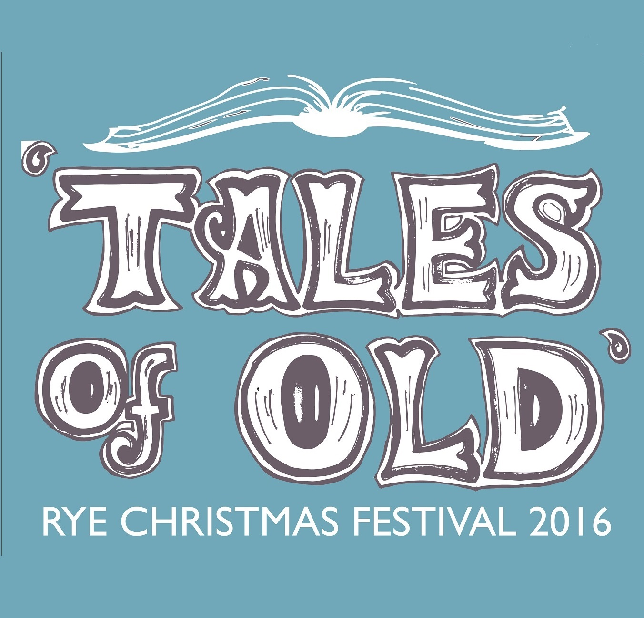
OLD TALE WRITING & ART COMPETITION REGISTRATION FORM

Children of all ages (0-99+) are invited to enter our Old Tale Competition.

You can enter a poem or even a tale of your own. What about rewriting one tale, changing the ending? You can enter a drawing or a sculpture too.

The winning entries will be displayed on the day of the event for all to see at St Mary’s Centre, Lion Street, Rye.

The stories and artistic creations might be inspired by this year theme of the ‘Tales of Old’.
For more information, please visit: http://www.christmasinrye.co.uk/embrace-the-theme

The registration form below together with your entry should be returned by Wednesday 30 November.
You can confirm your registration either by phone at 07455 383237 or electronically at caroline@christmasinrye.co.uk

______________________________________________________________________

REGISTRATION FORM - OLD TALE WRITING & ART COMPETITION 2016

Category: □ Children up to 7 □ Children 8-11 □ Young people 12-16 □ Adults 17+
Name of entrant:
Contact person (if entrant is less than 18 years old):
Contact details:
Title for your entry:
(*) brief description describing your entry (approximately 30 words):

